

Application of Linux Operating System

Samuel Attila Zemes

Dundalk Institute of Technology

Computing DK 721

16/12/2023

Contents

Introduction 3

Body Of Work 4

Necessary hardware components for Linux-based computers, 4

Kernel as part of Linux 5

Linux file management: 5

Shell as part of the user interface on Linux OS 6

Application definition: 7

The difference between heavyweight and Lightweight OS 8

System ageing 8

Linux VS Windows 11

Conclusion 11

References: 11

# Introduction

Linux is one of many operating systems in the computing world. It is one of many open-source operating systems, which means it has a wide range of support and usage within the user base. The main components of Linux consist of the Kernel, which manages the computer's hardware. Bash is a CLI language that interacts with the user. CLI enables a user to make a bash script or command. It is known that Linux as an Operating System acts as an intermediary between applications and devices. Since Linux is an open-source operating system, users develop multiple use cases for each device. That means the Core of the Linux operating system is used in phones (Android) and computers (Ubuntu, Kali Linux), and it is widely explored in servers (Ubuntu, Red Hat services). Like any operating system, it has its advantages.

Some of the advantages of Linux are:

* Stability
* Cost
* Customizability
* Security
* Community Support
* Networking Capabilities

This report explains the difference between the Linux and Windows OS while it looks into the Linux structure, progressing from the inner layer to the outer layer, as shown in Figure 1. The main topics covered are:

* 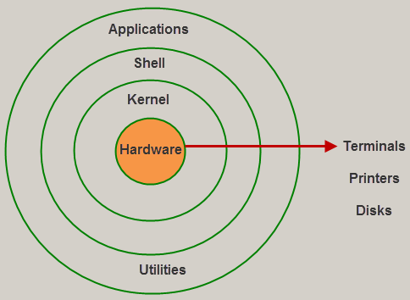Necessary hardware components for Linux-based computers,
* Kernel as part of Linux
* Shell as part of the user interface on Linux OS
* The difference between heavyweight and lightweight OS and why Linux is better for users.

Figure one: Structure of Linux OS

* System Ageing
* Most asked questions about Linux

# Body Of Work

## Necessary hardware components for Linux-based computers,

Hardware is the building stone of any PC. For hardware structure that gives meaning to the computer, we need:

* Motherboard – It is the keystone for any computer. To the motherboard, we connect all the hardware components & IOD (Input Output Devices), which are then communicated by a system bus that transfers all information to each computer element.
* CPU – It is the brain of a computer. It provides an essential function to process and execute the various programs by determining the length, importance, and how long the program has waited to be completed.
* GPU (Graphical Processing Unit)- It is designed for rendering and processing graphics on a user's PC Display. Their main task is to rend an image on a user's screen.
* Ram - Temporary memory storage that makes information immediately accessible to the CPU. The connection between RAM and CPU is caused by a higher system bus that passes the tasks to be executed.
* Drives – These are hardware devices that store information temporally or permanently to be accessible to the user anytime once the PC powers up. We are dividing them into SSD (**Solid-state drive)** and HDD (**Hard disk drive**)

These are the main components required to run Linux OS. One advantage of Linux is that it does not need modern and high-capacity specs to run it. Linux can be run on microcomputers such as Raspberry PI or any older computer.

## Kernel as part of Linux

The kernel is part of Linux and acts as a manager inside the hardware. The kernel acts as a bridge between hardware and the Linux shell and performs data processing at the hardware level using inner process communication and system calls. The most crucial for management are :

* operations of memory (Linux File System)
* CPU time and operations.
* Security – will hash essential data on a system like passwords. (can be found in /etc/shadow)
* Networking protocols – it manages NIC protocols to allow computers to connect to the internet.

Every task inside the hardware that the kernel manages is stored in the process table. This table is then loaded into an executable file and written into the memory as ‘exec’ in system calls. To find these system calls, we can use the command in the shell:

which exec

This will locate the path of executable files in Linux.

### Linux file management:

One of the responsibilities of the kernel in Linux is managing files. The Linux file system is unique in managing files, allowing users to specify who can access them, their ownership, and even execute bash scripts. For instance, if the kernel receives a request from the shell to run a script, it will start by looking at the path to find the location of the specified directory and then execute it. The root directory (/) is organised in a hierarchical tree-like structure, making it critical to understand the Linux file structure for operating systems. Some essential directories include:

Figure Two: Linux File System structure

* /bin – Represents what is known as Binaries. It is a directory that stores some of the fundamental commands used in bash scripting to run the administration in Linux.
* /boot – It is the directory that contains the boot loader. This directory always runs whenever the user starts or turns off the device.
* /etc – This directory contains system configuration on Linux device
* /home – Home directory for the users that are on the Linux system
* /var – This directory contains variable data that often changes, like log files and system databases
* /sbin – The /sbin contains System binaries and administrative tools needed for system maintenance

## Shell as part of user interface on Linux OS

The shell is a critical factor in how users interact with the Linux operating system. The shell works on the command lines issued by the user to perform various functions like file management, process management and network configuration. It provides two ways of interaction: a command-line interface (CLI) or a graphical user interface (GUI). The shell environment lets users execute commands, run applications, or manage kernel system tasks. The shell is an essential part of Linux.  
Most use commands that are widely used in shell or scripting are:

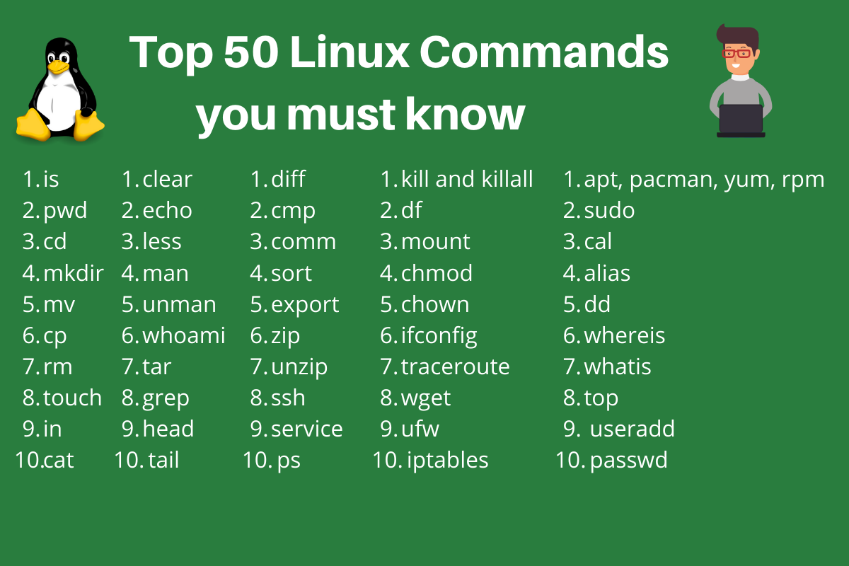

### Application definition:

The application layer is a layer in which user applications are running. They utilise the shell and kernel to run these applications. These applications can be classified as web browsers (using networking protocols), opening folders on screen (using Linux file management), video apps (using Kernel for managing GPU for rendering pictures on user screens), etc.

(This is the Linux structure. Let's compare it to other OS and explain why Linux is a better Operating system than Windows.)

## The difference between heavyweight and Lightweight OS

Software is needed to allocate these resources to the user when introducing the hardware. As users, we need to know suitable operating software with a structured design to provide the necessary utilities for our needs. These operating system structures are divided into:

1. **Heavyweight Operating System Distribution (Windows)**
2. **Lightweight Operating System Distribution (Linux)**

**Lightweight Operating System Distribution** is designed to come with less advanced built-in functionality. However, the user can decide whether to add additional functionality to the Lightweight Operating System, which makes this OS distribution flexible and optimal for the user who knows how to configure them.

That means Linux can be a home cinema or server. It can customise the OS according to the needs of the user.

**Heavyweight Operating Systems** are designed to come with general applicability for users that require already pre-build systems, like laypeople. These OS do not support customizability over time and become less optimal.

Moreover, the lifespan and the nonstop development of computer components and operating systems may force a user to replace parts and operating systems, but that costs money for improvement.

However, there is no guarantee that it will bring the desired result unless the computer hardware meets the requirements of the current operating system, which may lead to crashes and unnecessary problems. This is what we call **system ageing.**

## System ageing

Definition:

**System ageing** is an inability to keep up with current standards either in the hardware or software side of computer technology.

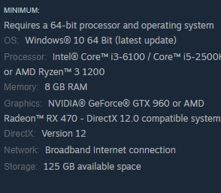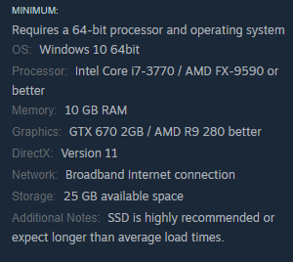Examples:

For example, there are pictures from games; the first picture on the right is from the 2023 game, and the second on the left is from the 2017 game. This example shows how minimal system requirements are to play the game and is meant to explain the effect of system ageing has an impact as time passes.

(Ageing effects on computer system)

We divided System ageing into two parts:

1. Software ageing
2. Hardware ageing

System Software ageing is the inability to run newer or updated user applications.

When discussing system software ageing, we generally refer to the Operating System (OS). The OS has several responsibilities, including providing an interface to user applications and ensuring security. In most cases, newer user applications assume that the user's OS can handle their demands and are compatible with the OS they are based on to access it. However, the OS requires updates to access the newest user applications and security measures. These updates can be installed until the user's computer hardware no longer supports them. We also need to consider that the newest user application is, the more resources it will require to transfer more computer hardware resources to run the application, thus degrading the lifespan of the user's computer hardware. To understand this, let’s put it into a formula:

$$Lifespan of computerdware compoments=\frac{User Applcation}{Hardware resources}$$

This only proves that user applications directly affect computer systems' lifespans. Choosing the right OS is essential. We, as users, must decide on what purposes we will use it for. If this choice is wrong and poorly thought out, it can lead to severe system hardware ageing.

System hardware ageing is whenever a user's computer hardware is the failure of a component to operate in the user's computer as was designed. This component is failing the user's computer system, which makes it unable to run the computer. One of the many symptoms of system hardware ageing can be data corruption, which means that all data on the drive are either fragmented or have lost some part of the file's structure, which means that drives reach their maximum lifespan and need to be replaced.

***Proper maintenance, including checking for updates, ensures our devices last longer***. ***That is the only way to prevent the system from ageing.***

## Linux VS Windows

As a user of both Windows and Linux, I have found that each operating system has its strengths and weaknesses. Linux, for instance, is a free and lightweight platform that can be easily customised to meet the user's specific needs. I highly recommend this type of OS for those who require nothing but essential services.

Regarding IT networking and cybersecurity, Linux has a clear advantage over Windows. Thanks to its customizability, Linux has given rise to specific OS, such as Kali Linux and Red Hat OS, designed to provide efficient service on servers and testing and security over a network.

On the other hand, Windows is a premium paid OS focused on the latest technologies and premium user applications. It also offers customer support to help users resolve any issues. Furthermore, it's worth noting that around 60% of devices worldwide are based on Windows. So, most user applications are based on Windows, which gives it an advantage over Linux.

But overall, a well-customised Linux has an edge over Windows. I would recommend that everyone use these types of Linux OS.

## Conclusion

This report analyses the structure of Linux. Explains how system ageing works on computer devices. We explored the necessary hardware components that are required for the Linux system. Explain the difference between lightweight and heavyweight OS. The report also highlights the benefits and strengths of each design and contains the author's experience and recommendations in the report.

# References:

Information about hardware: <https://www.techtarget.com/searchnetworking/definition/hardware>

Lightweight vs Heavyweight OS Definition :

https://www.partitionwizard.com/clone-disk/lightweight-linux-distro.html

Information about ageing: <https://ieeexplore.ieee.org/abstract/document/5355512/references#references>

What is GPU: <https://www.arm.com/glossary/gpus>

Information about kernel : https://www.geeksforgeeks.org/kernel-in-operating-system/?ref=lbp

https://www.alibabacloud.com/blog/what-is-linux-kernel_599980

file management : https://www.scaler.com/topics/linux-tutorial/file-system-of-linux/

Images : <https://tldp.org/LDP/intro-linux/html/sect_03_01.html>

<https://www.digitalocean.com/community/tutorials/linux-commands>

https://www.ssla.co.uk/linux-operating-system/

|  |  |  |  |
| --- | --- | --- | --- |
|   **Continuous Assessment Cover Sheet** | | | |
| **Student Name: Samuel Attila Zemes** | | **Student Number: D00260113** | |
| **Programme: Computing DK721** | **Stage:2** | | **Complete Student Checklist:**  Re-read brief □  References and Bibliography □  Proofread □ |
| **Module: Operating Systems and Virtualization** | | |
| **Due Date: 22/12/2023 5 PM** | **No. Pages:11** | |
| **Lecturer(s) Name: David O’Keffe** | | |
| **Assignment No. and/or Description/Topic:**  Application of Linux Operating System | | | **Mode of Submission:**  Softcopy □ Hardcopy □ |
| **DECLARATION**: **I declare that:**   * This work is entirely my own, and no part of it has been copied from any other person’s words or ideas,   except as specifically acknowledged through the use of inverted commas and in-text references;   * No part of this assignment has been written for me by any other person except where such collaboration has been authorised by the lecturer(s) concerned; * I have not used generative artificial intelligence (AI) (e.g. ChatGPT) unless it has been permitted by the lecturer(s) concerned; * I understand that I am bound by DkIT Academic Integrity Policy. I understand that I may be penalised if I have violated the policy in any way; * This assignment has not been submitted for any other module at DkIT or any other institution, unless authorised by the relevant Lecturer(s); * I have read and abided by all of the requirements set down for this assignment.   **Signature**……………………………………………………..…………………………………………………… **Date**…22/12/2023……………..………… | | | |

**Lecturer’s Comments:**

**Provisional Mark : Lecturers Signature : Date:**

*Work submitted late will be subject to penalties in accordance with the DkIT Continuous Assessment Policy*